Objective:

Easy access and visualization to log file by service.

Features needed:

1. Histogram
2. Dropdown box
3. Receive arguments from command line
4. Can process multiple files
5. Categories: linked, unlinked, RFiD
6. Analysis: tray arrives too late / too early
7. Indicate: no bag / loose item

What I have:

1. Process single txt file
2. Histogram for all data by showing all beam difference
3. Find unaccepted RFiD by diff value

What I plan to do:

1. Process multiple files (on the same folder?)
2. Make program to receive command arguments
3. Check file exist or not
4. Development based on OOP
5. PyQt display UI
6. Be able to choose specific RFid from histogram (by mouse or elsewhere)

References:

How do I check whether a file exists without exceptions? <https://stackoverflow.com/questions/82831/how-do-i-check-whether-a-file-exists-without-exceptions>

File not in directory, user re-enters file name (loop) <https://stackoverflow.com/questions/34600021/file-not-in-directory-user-re-enters-file-name-loop-python>

How to get user input repeat until I want to quit? <https://stackoverflow.com/questions/12608654/how-to-get-user-input-repeatly-until-i-want-to-quit>

How to create pandas data frame from multiple lists? <http://cmdlinetips.com/2018/01/how-to-create-pandas-dataframe-from-multiple-lists/>

Convert the column type from string to datetime format in Pandas dataframe <https://www.geeksforgeeks.org/convert-the-column-type-from-string-to-datetime-format-in-pandas-dataframe/>

How would I get everything before a : in a string Python <https://stackoverflow.com/questions/27387415/how-would-i-get-everything-before-a-in-a-string-python/27387468>

Developing GUIs in Python: Tkinter vs PyQt

<https://stackoverflow.com/questions/1094155/developing-guis-in-python-tkinter-vs-pyqt>

Tk dropdown example

<https://pythonspot.com/tk-dropdown-example/>

[Solved my issue] Spyder crashes with Pyqt5.12 (PyQt5-5.14.1)

<https://github.com/spyder-ide/spyder/issues/8868>

[Solved my issue] Creating a pop-up window from custom pushbutton python <https://stackoverflow.com/questions/48768817/creating-a-pop-up-window-from-custom-pushbutton-python>

PyQt5 Image <https://pythonspot.com/pyqt5-image/>

Find Index of last occurrence of substring in a string <https://stackoverflow.com/questions/9572490/find-index-of-last-occurrence-of-a-substring-in-a-string>

Object-Oriented Programming (OOP) in Python3 <https://realpython.com/python3-object-oriented-programming/>

Importing class from another file <https://stackoverflow.com/questions/41276067/importing-class-from-another-file>

PyQt – QmessageBox <https://www.tutorialspoint.com/pyqt/pyqt_qmessagebox.htm>

PyQt5 textbox example <https://pythonspot.com/pyqt5-textbox-example/>

PyQt5 image <https://stackoverflow.com/questions/51430586/pyqt5-how-to-display-image-in-qmainwindow-class>

Parsing Log file in Python and saving it to csv <https://stackoverflow.com/questions/44825779/parsing-log-file-in-python-and-saving-it-to-csv>

Display Pandas DataFrame with PyQt5 QTableView Widget <https://learndataanalysis.org/display-pandas-dataframe-with-pyqt5-qtableview-widget/>

Qt Stylesheets Button Bar Tutorial: <https://thesmithfam.org/blog/2009/09/17/qt-stylesheets-button-bar-tutorial/>

Python timestamp to datetime: <https://www.programiz.com/python-programming/datetime/timestamp-datetime>

pip install PyQtChart

<https://pypi.org/project/PyQtChart/>

Cannot load library /usr/local/lib64/python3.6/site-packages/PyQt5/Qt/plugins/platforms/libqxcb.so: (libxkbcommon-x11.so.0: cannot open shared object file: No such file or directory)

QLibraryPrivate::loadPlugin failed on "/usr/local/lib64/python3.6/site-packages/PyQt5/Qt/plugins/platforms/libqxcb.so" : "Cannot load library /usr/local/lib64/python3.6/site-packages/PyQt5/Qt/plugins/platforms/libqxcb.so: (libxkbcommon-x11.so.0: cannot open shared object file: No such file or directory)"

qt.qpa.plugin: Could not load the Qt platform plugin "xcb" in "" even though it was found.

This application failed to start because no Qt platform plugin could be initialized. Reinstalling the application may fix this problem.

<https://www.riverbankcomputing.com/pipermail/pyqt/2019-February/041363.html>

<https://centos.pkgs.org/7/centos-x86_64/libxkbcommon-x11-0.7.1-3.el7.x86_64.rpm.html>

<https://centos.pkgs.org/7/centos-x86_64/libxkbcommon-x11-devel-0.7.1-3.el7.x86_64.rpm.html>

Downgrade Pyqt to 5.11.3

$ pip3 install --upgrade --user pyqt5==5.11.3

<https://github.com/spyder-ide/spyder/issues/8868>

23:

2-3: 422s

Tab widget: <https://pythonbasics.org/pyqt-tabwidget/>

Python installation on centOS: <https://tecadmin.net/install-python-3-6-on-centos/>

Qt5 installation on centOS: <https://superuser.com/questions/1237932/please-help-installing-qt-centos-7/1239219>

PyQt5 LineChart: <https://codeloop.org/pyqtchart-how-to-create-linechart-in-pyqt5/>

<http://www.programmersought.com/article/6571224980/>

live chart: <https://doc.qt.io/qt-5/qsplineseries.html>

<https://blog.csdn.net/lmhuanying1012/article/details/78455037>

Unittest: <https://docs.python.org/3/library/unittest.html#unittest.main>

<https://developer.51cto.com/art/201904/595162.htm>

Unittest on GUI: <http://johnnado.com/pyqt-qtest-example/>

<https://riverbankcomputing.com/pipermail/pyqt/2011-August/030314.html>

<https://stackoverflow.com/questions/3942820/how-to-do-unit-testing-of-functions-writing-files-using-python-unittest>

uniites and config: <https://stackoverflow.com/questions/714063/importing-modules-from-parent-folder>

<https://martin-thoma.com/configuration-files-in-python/>

Save output to separate folder: <https://www.daniweb.com/programming/software-development/threads/232168/save-a-file-in-a-directory-python>

Find location of site-packages: <https://stackoverflow.com/questions/122327/how-do-i-find-the-location-of-my-python-site-packages-directory>

Python dictionary to JSON: <https://appdividend.com/2019/04/15/how-to-convert-python-dictionary-to-json-tutorial-with-example/>

First project in PyCharm: <https://www.jetbrains.com/help/pycharm/creating-and-running-your-first-python-project.html>

Grid Layout change row height: <https://stackoverflow.com/questions/39806482/qgridlayout-change-height-of-a-row>

<https://www.delftstack.com/tutorial/pyqt5/pyqt-grid-layout/#pyqt5-grid-layout-span>

<https://doc.qt.io/qt-5/layout.html>

Installed packages in CentOS: <https://www.cyberciti.biz/faq/check-list-installed-packages-in-centos-linux/>

PyCharm: <https://www.simplifiedpython.net/6-best-python-ides/>

Panda fill N/A data: <https://pandas.pydata.org/pandas-docs/stable/user_guide/missing_data.html>

PyQt5 to exe Pyinstaller: <https://pyinstaller.readthedocs.io/en/stable/spec-files.html#adding-files-to-the-bundle>

<https://github.com/pyinstaller/pyinstaller/issues/3971>

<https://pyinstaller.readthedocs.io/en/stable/operating-mode.html>

<https://medium.com/@liron92/pyinstaller-with-pandas-problems-solutions-and-workflow-with-code-examples-c72973e1e23f>

<https://pythonhosted.org/PyInstaller/hooks.html>

Donut chart (unlinked summary): <https://codeloop.org/pyqtchart-how-to-create-donutchart-in-pyqt5/>

<https://github.com/jonathanferreyra/pyqt-morris>

Chart Theme: <https://doc.qt.io/qt-5/qchart.html#ChartTheme-enum>

Qt Spacer: <https://doc.qt.io/qtforpython/PySide2/QtWidgets/QSpacerItem.html>

<https://www.programcreek.com/python/example/108080/PyQt5.QtWidgets.QSpacerItem>

Label align right & center: <https://stackoverflow.com/questions/24965060/how-to-align-qlabel-text-to-labels-right-edge>

Get formatted date time (epoch to date time): <https://stackoverflow.com/questions/12400256/converting-epoch-time-into-the-datetime>

<https://www.journaldev.com/23365/python-string-to-datetime-strptime>

Write ReadMe: <https://www.makeareadme.com/>

<https://tom.preston-werner.com/2010/08/23/readme-driven-development.html>

template: <https://gist.github.com/PurpleBooth/109311bb0361f32d87a2>

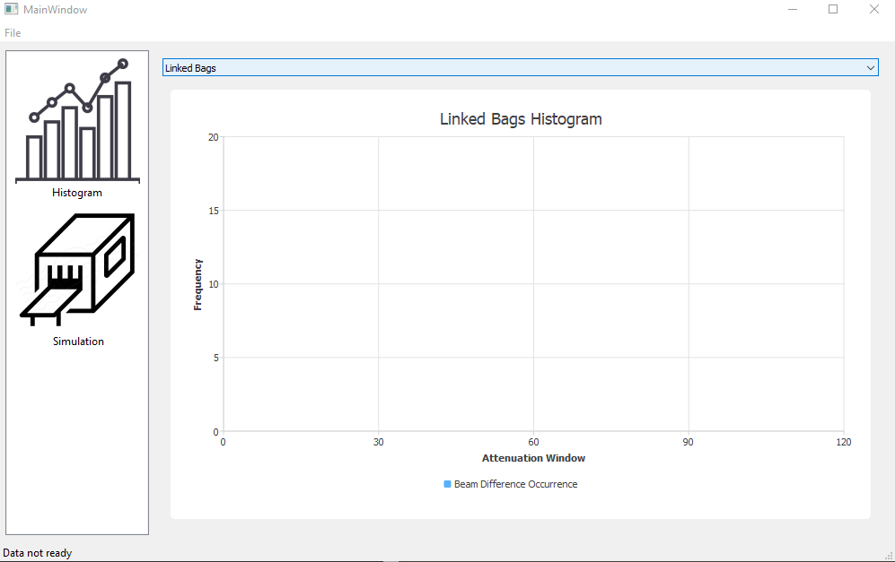

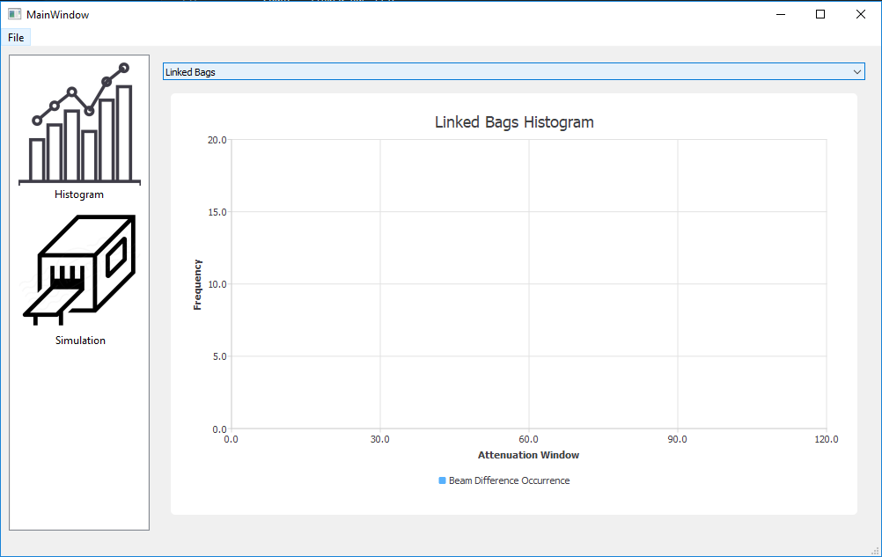

Simulation total running time after delays:

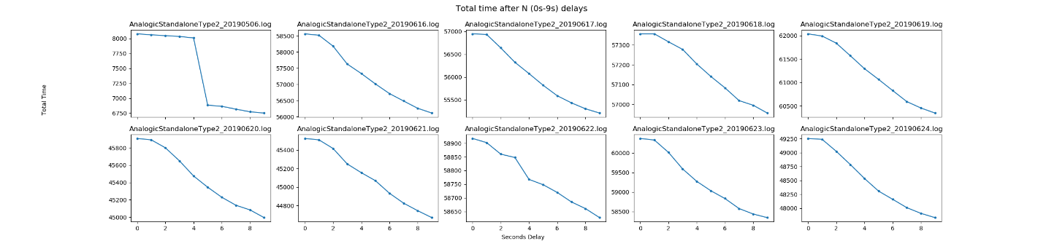

Figure 1. Total time after N delays (N = 0s – 9s)

Figure 1 shows the total time after N seconds delay, it decreases as the delay seconds goes up. The best delay number is indicated by calculating the difference between total time after delay gaps. By observing the largest gap, which means save the huge amount of time on the machine process.

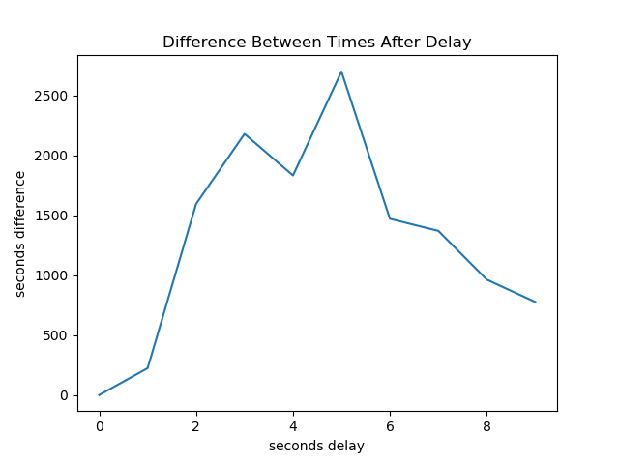

Figure 2. Difference between times after delay

In the Figure 2, the two peaks at 3 seconds and 5 seconds means relatively increases a lot compares to the previous delay (1 seconds earlier). This result given by 10 log files show that the 3s and 5s have the best performance after delay.

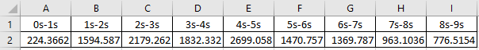

Chart 1. Time Difference among 10 log files

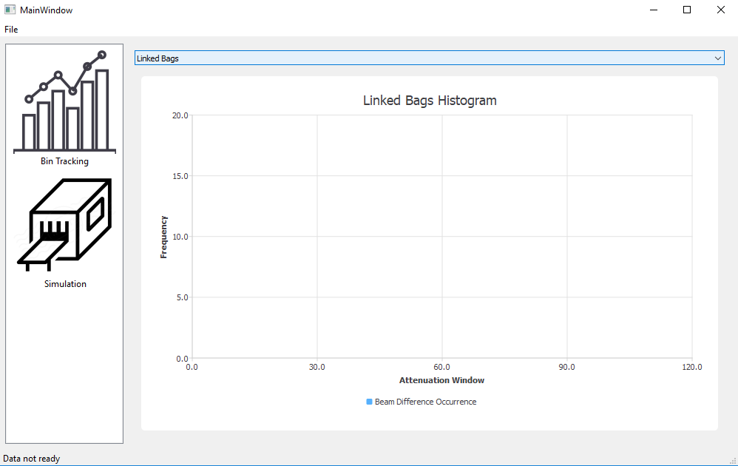

Figure 3. Empty Linked Bins Histogram (no data handling)

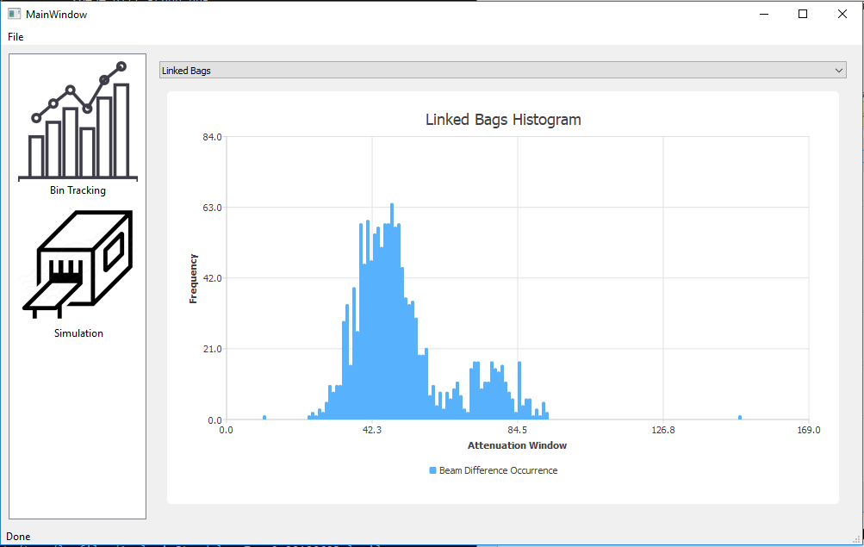

Figure 4. Linked Bins Histogram with data

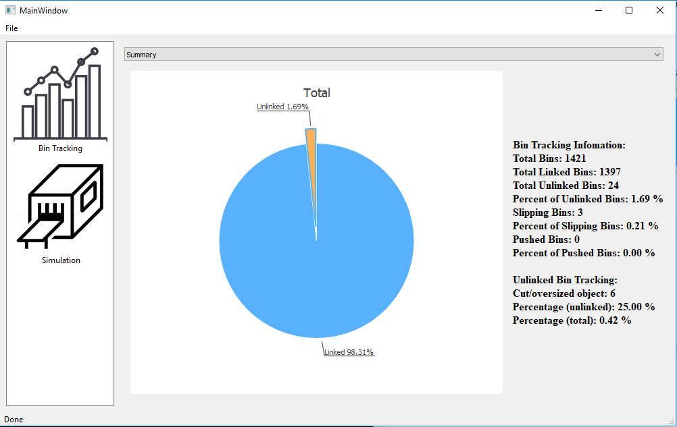

Figure 5. Summary pie chart with information

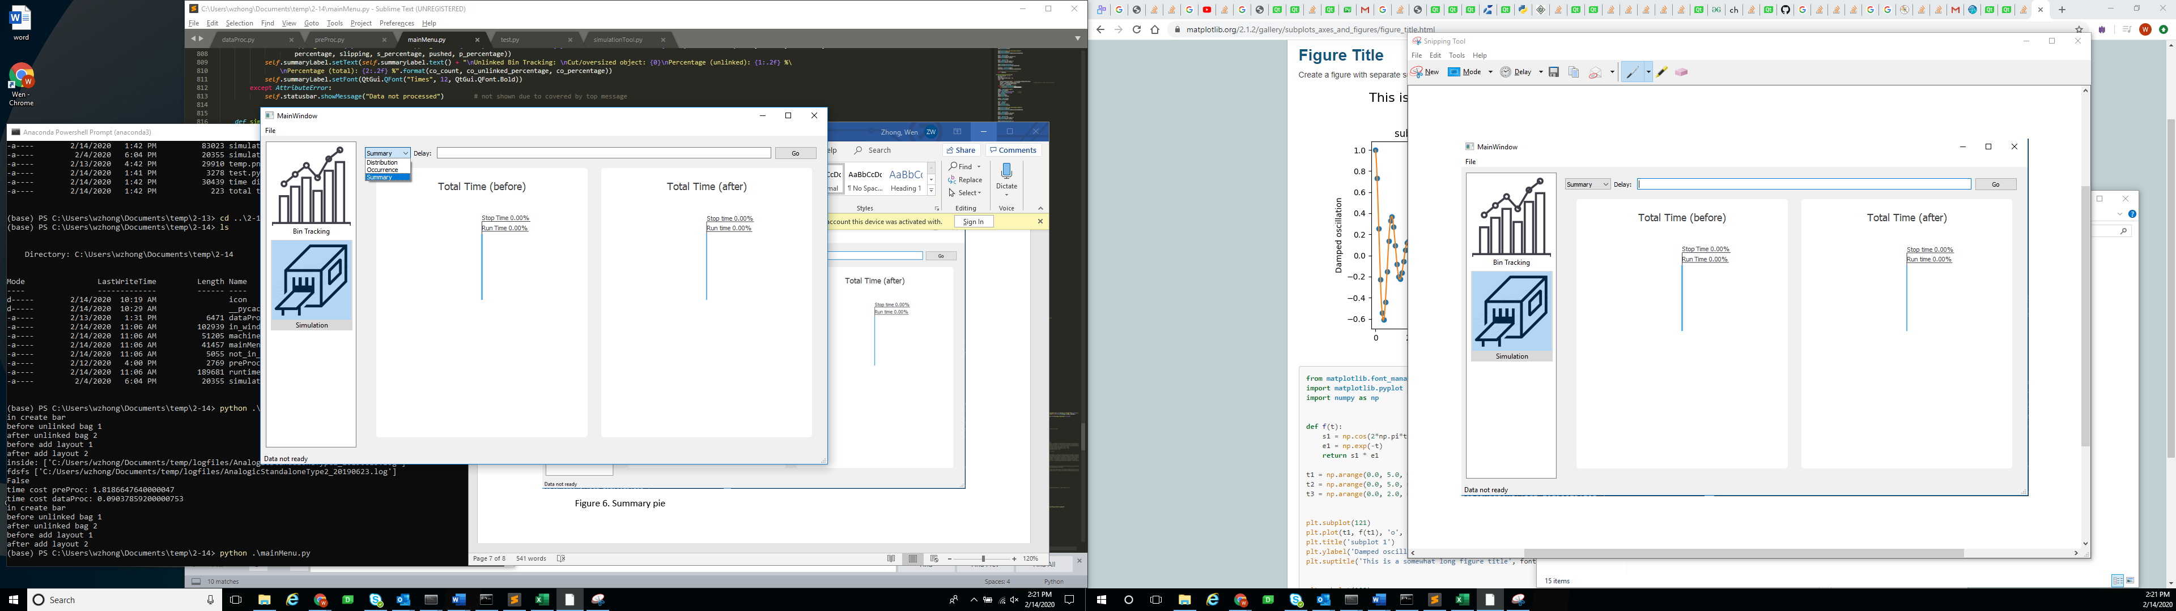

Figure 6. Different Chart to Choose and Empty Summary Pie Chart

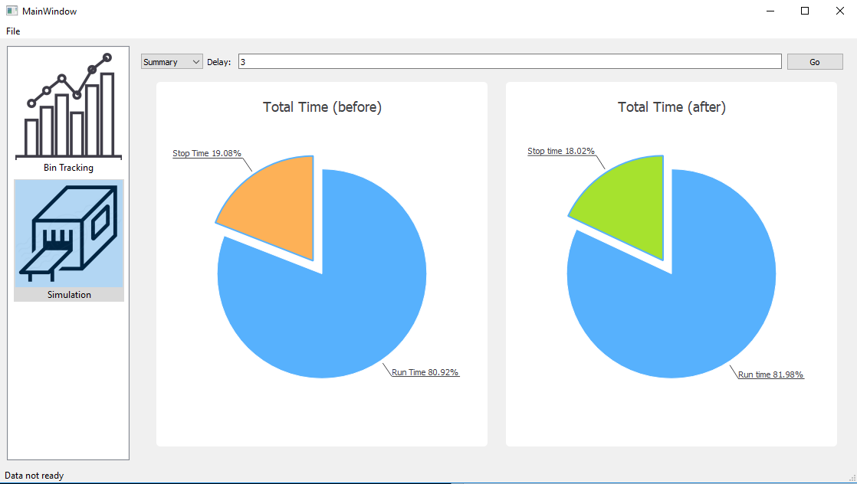

Figure 7. Summary pie chart on time before/after delay

Outline:

**Bin Tracking**

* Linked Bins Histogram
* Unlinked Bins Summary
* Summary Pie Chart with information label

*\*Error handling when data is not ready (1. Show empty chart; 2. Show “data not ready” message.)*

**Simulation**

* Distribution Histogram (stop time)
* Occurrence Histogram (stop time)
* Summary before/after (stop/run time)

*\*Error handling when data is not ready (1. Show empty chart; 2. Show “data not ready” message.)*

*\*\*Error handling when corresponding file is not generated yet (1. Show empty chart; 2. Show “data not ready” message.)*

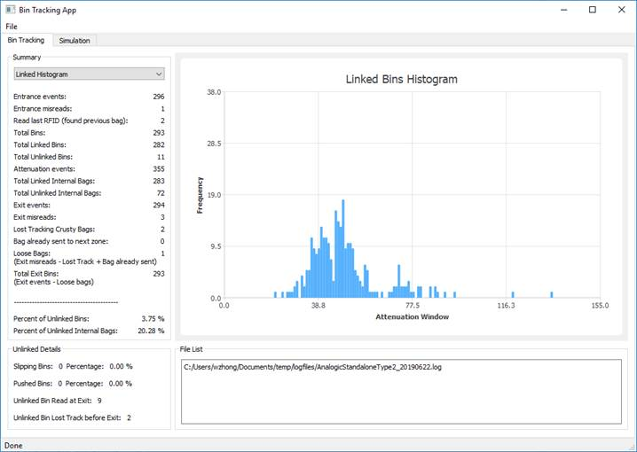

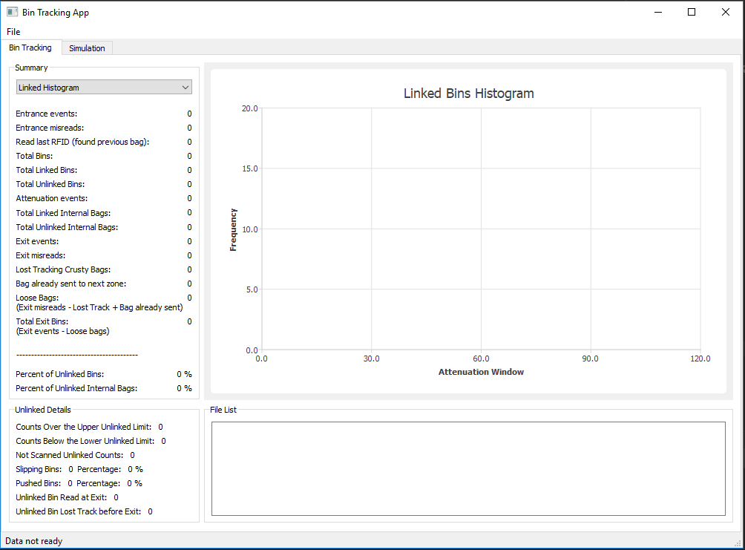

Idle layout (0 on each cell data)

Added “Counts Over the Upper Unlinked Limit: ”

“Counts Below the Lower Unlinked Limit: ”

“Not Scanned Linked Counts: ” to UI.

Added “unlinked_list” (contains all unlinked bins, after merge with unlinked_RFID this will only contain unlinked bins that scanner doesn’t know)

“unlinked_RFID” (contains all unlinked bins, get by compare unlinked_list with unlinked) to data.

4/16/20

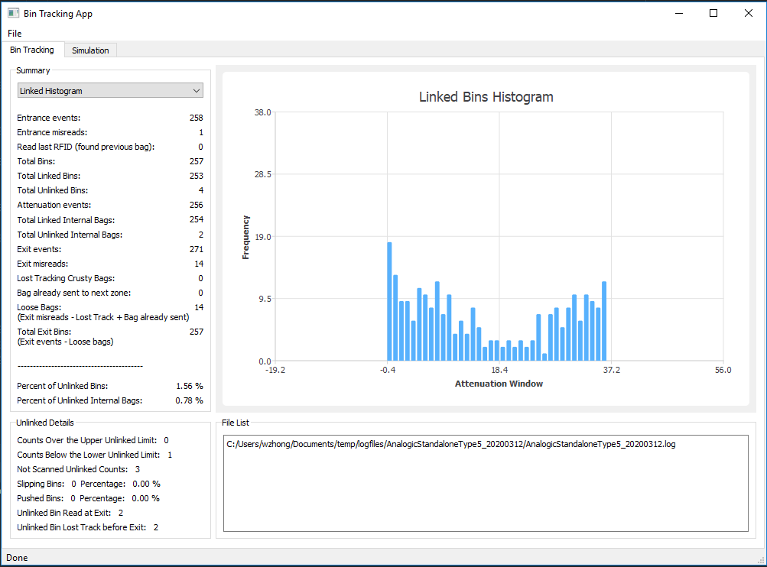

Execution layout (data shows on corresponding cell)

Total unlinked = Count over the upper unlinked limit + counts below the lower unlinked limit + not scanned unlinked counts

In this case, total unlinked = 0 + 1 + 3 = 4

The same as next statement given,

Total unlinked = unlinked bin read at exit + unlinked bin lost track before exit

That is, total unlinked = 2 + 2 = 4

--------------------------------------------------------------

4.16.2020

Final UI: 